**AWS WITH PYTHON | PART 2 : EC2**

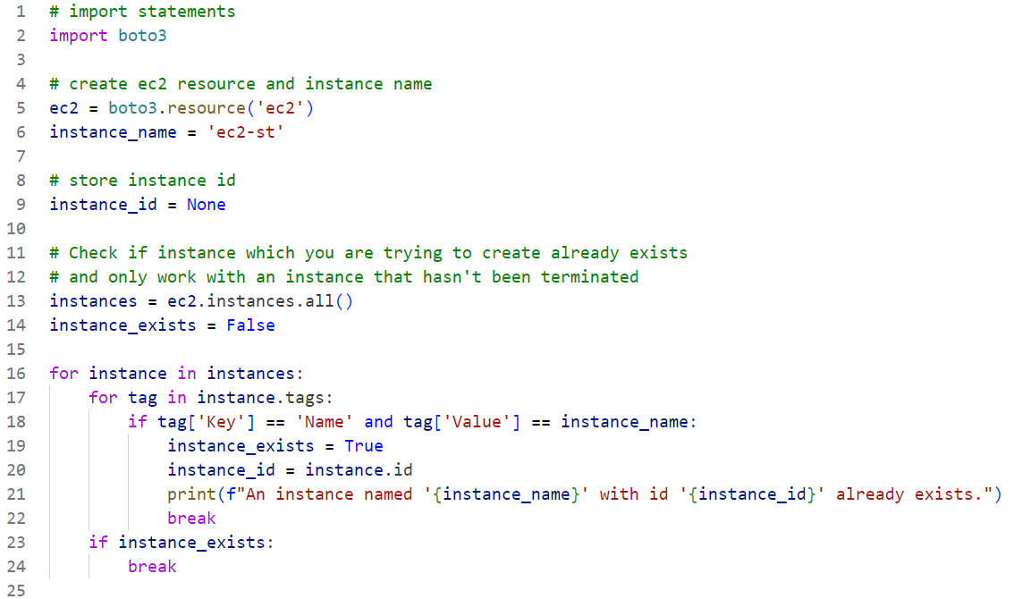

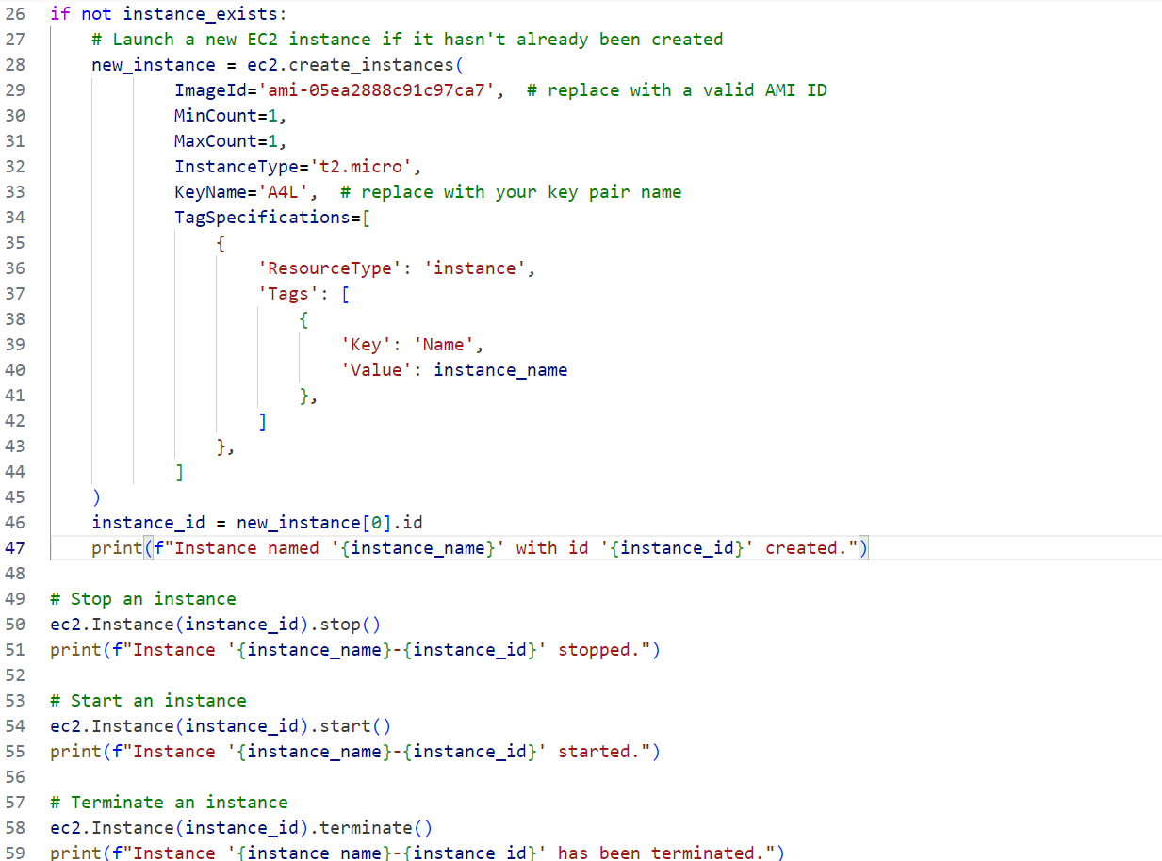

**CODE BREACKDOWN**

### **1. Import Statements**

* **boto3**: This is the AWS SDK for Python that allows you to interact with AWS services.

### **2. Create EC2 Resource and Instance Name**

* **ec2 = boto3.resource('ec2')**: This creates a high-level resource object for interacting with EC2 instances.
* **instance_name = 'st-ec2-hol'**: This sets the name of the EC2 instance you are looking for or creating.

### **3. Store Instance ID**

* **instance_id**: A variable to store the ID of the EC2 instance if it is found or created.

### **4. Check if Instance Already Exists**

* **instances = ec2.instances.all()**: Retrieves all EC2 instances.
* **instance_exists = False**: Initializes a flag to check if the instance exists.
* The for loop iterates through each instance and its tags to find one with the name st-ec2-hol.
* If an instance with that name is found, it sets instance_exists to True, stores the instance ID, and prints a message.

### **5. Launch a New EC2 Instance**

* **if not instance_exists:**: Checks if the instance does not exist.
* **ec2.create_instances(...)**: Launches a new EC2 instance with specified parameters:
  + **ImageId**: The ID of the Amazon Machine Image (AMI) used to launch the instance. Replace 'ami-05ea2888c91c97ca7' with a valid AMI ID for your region.
  + **MinCount and MaxCount**: Specifies the number of instances to launch.
  + **InstanceType**: Specifies the instance type (e.g., t2.micro).
  + **KeyName**: The key pair name used to connect to the instance.
  + **TagSpecifications**: Tags the instance with a Name key for identification.
* **new_instance[0].id**: Retrieves the ID of the newly created instance.
* Prints a confirmation message.

### **6. Stop the Instance**

* **ec2.Instance(instance_id).stop()**: Stops the instance with the specified ID.
* Prints a confirmation message.

### **7. Start the Instance**

* **ec2.Instance(instance_id).start()**: Starts the stopped instance with the specified ID.
* Prints a confirmation message.

### **8. Terminate the Instance**

* **ec2.Instance(instance_id).terminate()**: Terminates the instance with the specified ID.
* Prints a confirmation message.

### **Summary**

* This script first checks if an EC2 instance with a specific name exists.
* If it does not, it creates a new instance with that name.
* After that, it stops, starts, and then terminates the instance, printing messages at each step.